

Project-based Practical Report on

“Vehicle Service Management System”

Submitted in partial fulfilment of the requirements for “Practical Course Title” for the 1st Semester

Master of Computer Applications (MCA)

Submitted by

<KURIAN ROBERT> <26MCAC28>

Under the guidance of
<Dr.Nithya B>

Contents

1. Title of the Project
2. Introduction
3. Objective of the Project
4. Scope of the Project
5. Software Specifications
6. Workflow of the Project
7. Modules of the Project - Phase-wise explanation of design and execution of Modules
8. Source Code (Only functional code structure)
9. Features of the Project
10. Future Enhancements
11. Conclusion

1. Title of the Project
Vehicle Service Management System (VSMS)

2. Introduction
The Vehicle Service Management System (VSMS) is a comprehensive internal administrative web application designed to digitize, centralize, and streamline the daily operations of modern automobile service centers. Historically, vehicle repair stations have relied heavily on manual, paper-based record-keeping or fragmented digital spreadsheets to track customer details, mechanic schedules, service histories, and financial transactions. These traditional methods are highly susceptible to data loss, human error, and operational bottlenecks, making it difficult for shop managers to maintain a real-time overview of their business operations and workforce allocation.

To address these persistent industry challenges, VSMS provides a highly automated, single-pane digital dashboard tailored specifically for internal staff and administrators. By transitioning from physical ledgers to a centralized database, the application ensures seamless, end-to-end management of the core business entities: customers, vehicles, mechanics, assigned service tasks, and final billing. This digitization allows for instantaneous retrieval of a vehicle's complete service history, guarantees that customer profiles are accurately maintained, and ensures that mechanics are efficiently assigned to incoming repair jobs without scheduling conflicts.

Technologically, the application is engineered on a robust Model-View-Controller (MVC) design pattern, built entirely without the reliance on heavy external frameworks to ensure lightweight performance and high maintainability. The system utilizes raw Java Servlets to handle all backend processing, server-side routing, and business logic execution. The presentation layer is crafted using HTML and CSS to offer a clean, responsive, and intuitive interface for shop administrators. For data persistence and structural integrity, VSMS integrates a relational MySQL database, employing strict database normalization and foreign key constraints to guarantee that all data points remain deeply connected, secure, and instantly accessible.

3. Objective of the Project
The core objective is to develop a centralized dashboard that enables service center administrators to execute full CRUD (Create, Read, Update, Delete) operations. Specific goals include:
- Guaranteeing data integrity by enforcing strict relational database constraints between customers, vehicles, and service histories.
- Optimizing service workflows by accurately assigning mechanics to specific vehicle repairs.
- Providing a secure, authenticated environment tailored exclusively for internal staff operations.

4. Scope of the Project
The current scope encompasses backend administrative operations. It is restricted to an internal portal accessible only via secure login by shop managers and staff. The application handles customer profiling, vehicle registration, mechanic scheduling, and service logging. It explicitly excludes a public-facing customer portal or online appointment booking system in its current phase.

5. Software Specifications
- Frontend: HTML5, CSS3, JavaScript (Vanilla)
- Backend: Java (JDK 17+), Java Servlet API
- Database: MySQL 8.0+ (Relational Database Management System)
- Dependencies: MySQL Connector/J (JDBC), Google Protocol Buffers (Protobuf)
- Web Server: Apache Tomcat 10.1.60
- IDE/Environment: Visual Studio Code (VS Code)

6. Workflow of the Project
The application operates on a stateless Request-Response HTTP cycle managed by the Apache Tomcat server.
- Authentication: The Admin inputs credentials; the LoginServlet validates these against the users table.
- Navigation: Upon success, the admin accesses the Dashboard to select a module (e.g., Customer Management).
- Data Submission: The admin fills an HTML form and submits a POST request to a dedicated Servlet (e.g., AddCustomerServlet).
- Processing & Persistence: The Servlet parses the request parameters, establishes a JDBC connection, and executes a parameterized SQL query to update the database.
- Response: The Servlet redirects the admin back to the updated UI view.

6.1 Workflow Diagram Representation:
(Note for drawing: Create a flowchart with the following sequential nodes)
[Admin Browser] → (HTTP POST Credentials) → [Tomcat Server (LoginServlet)] → (JDBC Query) → [MySQL Database]
[MySQL Database] → (Returns Validation) → [LoginServlet] → (Redirects to Dashboard) → [Admin Browser]
[Admin Browser] → (Fills Form) → [AddCustomerServlet] → (SQL INSERT) → [MySQL Database] → (Updates & Redirects) → [Admin Browser]
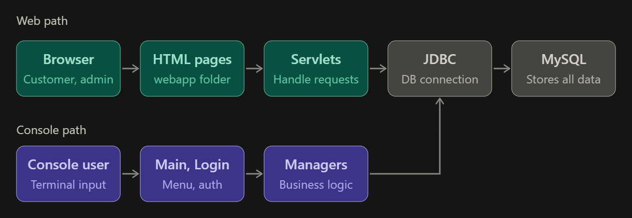

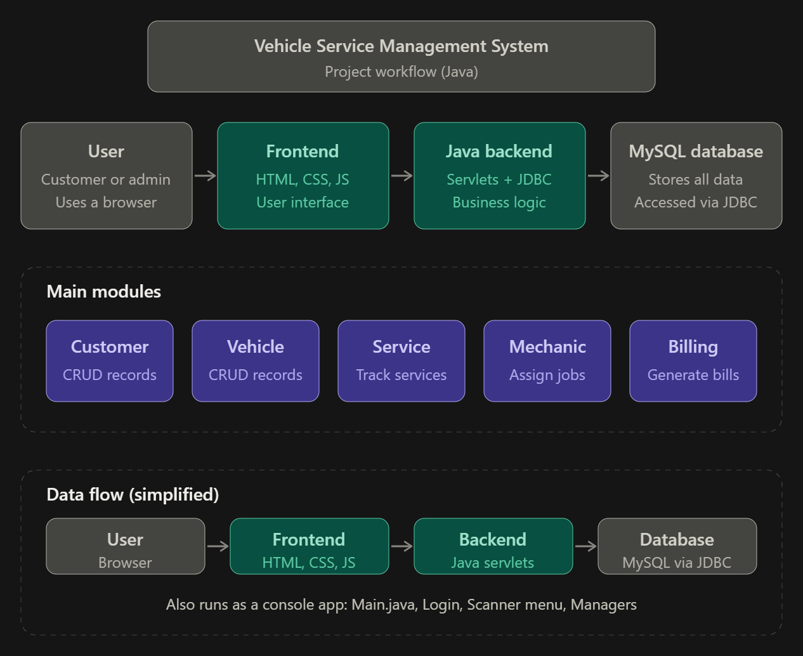

7. Modules of the Project - Phase-wise explanation of design and execution of Modules
- Phase 1: Authentication Module
  - Design: The frontend consists of a secure HTML login interface. The backend relies on a users table in the MySQL database containing authorized administrator credentials.
  - Execution: When an admin attempts to log in, the LoginServlet intercepts the HTTP POST request. It uses JDBC to query the database and validate the username and password. Upon successful execution, a session is created, and the admin is redirected to the main dashboard.
- Phase 2: Customer Management Phase
  - Design: This phase features a dashboard form allowing admins to input client data (Name, Phone, Email). In the database, the customers table acts as the primary hierarchical node, generating a unique customer_id for each new entry.
  - Execution: The AddCustomerServlet retrieves the form parameters and executes an INSERT SQL statement. The servlet instantly updates the UI to reflect the newly added customer, allowing the shop to maintain an accurate digital client ledger.
- Phase 3: Vehicle Management Phase
  - Design: The vehicle registration interface is designed to map specific vehicles to their respective owners. The database utilizes Foreign Keys to map the customer_id into the vehicles table, ensuring strict relational integrity.
  - Execution: The system dynamically populates a dropdown of existing customers. When the admin registers a vehicle (Make, Model, License Plate), the servlet executes the relational binding,ensuring that no vehicle can exist in the system without a registered owner.

- Phase 4: Service & Mechanic Operations Phase
  - Design: This is the operational core of the application. The frontend provides a comprehensive form to log repair tasks. The database design here is complex, bridging data from the vehicles, mechanics, and services tables.
  - Execution: The execution involves linking a logged service task to a specific vehicle_id and an assigned mechanic_id. The servlet tracks the ongoing repair status, processes updates when the job is marked complete, and calculates the final cost for billing purposes.

Data Flow Diagram (DFD) Models:
(Note for drawing: Create standard DFD diagrams based on these structures)
Level 0 DFD (Context Diagram):
- External Entity: Admin / Shop Manager
- Process (Center): Vehicle Service Management System (0.0)
- Data Flow: Admin sends "Login Credentials, Customer Data, Vehicle Data, Service Details" into the System. The System returns "Status Confirmations, Dashboard Views, Generated Bills" to the Admin.

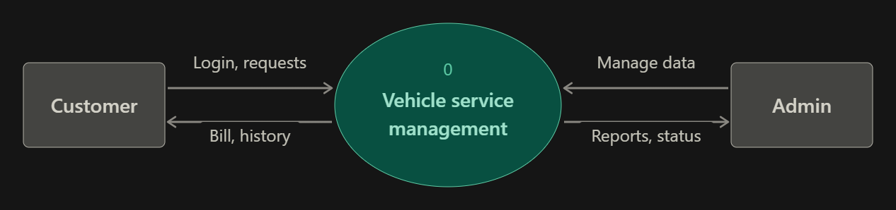
Level 1 DFD:
- Process 1.0 (Authentication): Validates Admin credentials against the Users DB.
- Process 2.0 (Manage Customers): Takes input from Admin, stores data in Customers DB, retrieves customer list.
- Process 3.0 (Manage Vehicles): Takes vehicle details, validates customer_id from Customers DB, stores in Vehicles DB.
- Process 4.0 (Manage Services): Takes repair logs, links data from Vehicles DB and Mechanics DB, outputs updated records to Services DB.

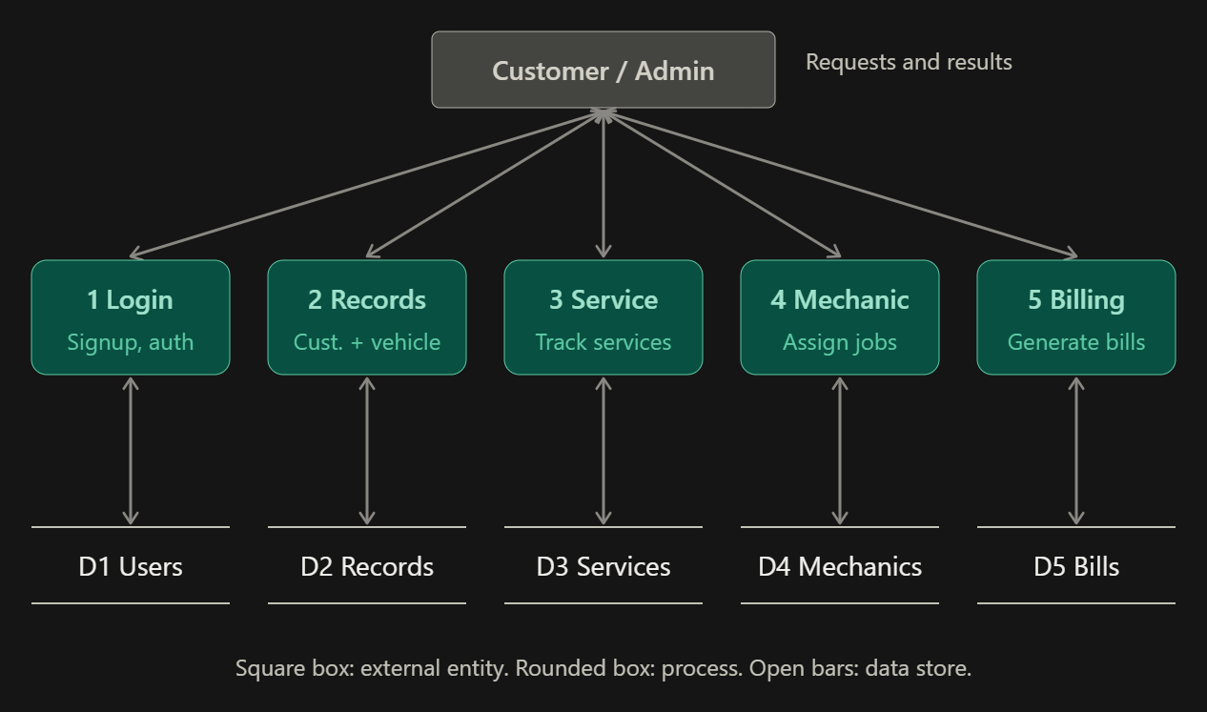

8. Source Code (Only functional code structure)
To maintain documentation neatness, structural excerpts are provided rather than the full codebase.

Controller Logic (AddCustomerServlet.java):
Java
import jakarta.servlet.annotation.WebServlet;
import jakarta.servlet.http.*;
import java.sql.*;

@WebServlet("/AddCustomerServlet")
public class AddCustomerServlet extends HttpServlet {
@Override
protected void doPost(HttpServletRequest request, HttpServletResponse response) {
String name = request.getParameter("customerName");
String phone = request.getParameter("customerPhone");

try (Connection conn = DatabaseConnection.getConnection()) {
String sql = "INSERT INTO customers (name, phone) VALUES (?, ?)";
PreparedStatement ps = conn.prepareStatement(sql);
ps.setString(1, name);
ps.setString(2, phone);
ps.executeUpdate();

response.sendRedirect("customer-management.html");
} catch (Exception e) {
e.printStackTrace();
}
}
}

9. Features of the Project
- Strict Relational Integrity: Utilizes MySQL foreign keys (e.g., ON DELETE CASCADE) to prevent orphaned vehicle or service records if a customer profile is removed.
- Direct Tomcat Deployment: Compiled Java .class files are executed directly from the WEB-INF/classes directory, ensuring lightweight server performance without heavy frameworks.
- Dynamic Frontend Search: Implements client-side JavaScript filtering on the HTML tables for instant data retrieval.

10. Future Enhancements
- Public Customer Portal: Establishing a secure login layer for clients to remotely track the live status of their vehicle repairs.
- Automated Notifications: Integrating JavaMail API or SMS gateways to automatically alert customers upon service completion.
- Inventory Tracking: Expanding the database to monitor spare part quantities and automatically deduct stock when assigned to a specific repair ticket.

11. Conclusion
The Vehicle Service Management System effectively resolves the inefficiencies associated with manual automotive repair administration. By integrating a clean HTML frontend with a powerful Java Servlet and MySQL backend, the project delivers a fast, secure, and scalable local web application. The strict adherence to MVC principles and relational database design ensures that the system is not only robust for immediate administrative use but also well-structured for future functional expansions.

